CS181
Final Project: Cartoonifying Images
Tianyuan Cai & Sara Gong

Introduction
We decided to do our project on cartoonifying images, or turning photorealistic pictures into cartoons. When we first saw the topic, we thought about how cartoonifying images has wide applications in social media. Many mobile apps use image processing algorithms to output images with interesting effects. For example, Snapchat has filters that allow users to cartoonify what they see on the camera in real time. So we thought that cartoonifying’s main application would be in situations like these for people to have fun with their online presence. We also thought that it could be applicable to animation, but it is probably rare for cartoonified photorealistic images to be used in actual cartoons.

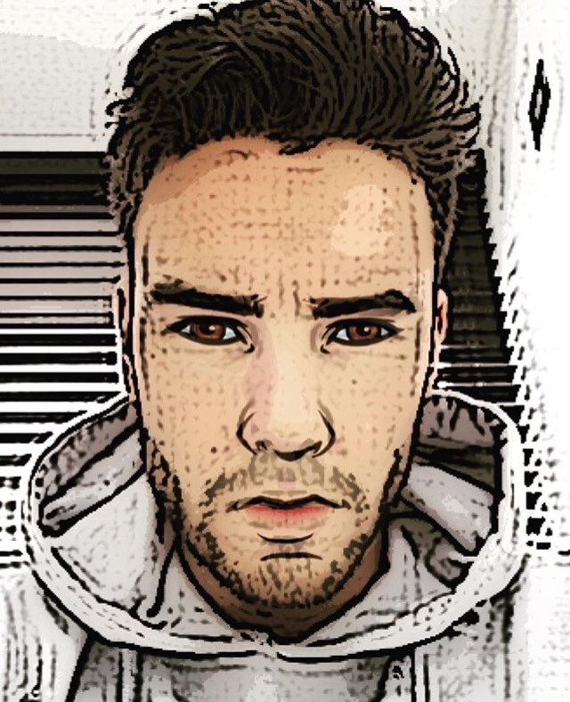
Snapchat cartoonifying filter applied on a selfie

After doing some research, we learned about other, more practical aspects of cartoonifying - privacy and support for the hearing impaired. For cases of surveillance, assisted living, or home monitoring, cartoonifying would be applicable because it would retain the privacy of the people being monitored without limiting how useful the surveillance system can be (Erdélyi et al, 2014). Cartoonifying can abstract away image details such as facial features and landmarks, making it possible to use the footage without compromising the privacy of anyone in the video. Mostly, people watch security camera footage to observe behavior, and that is still recognizable even after the videos are cartoonified. The article we read about this application of cartoonification also compared cartoonification to blurring and pixelation, which are two other common techniques used to protect privacy in surveillance. However, they found that although blurring and pixelation protect privacy, they also make it very difficult to observe what is happening in the video. Cartoonifying, though, does not have that problem because general shapes are retained.
The other practical application of cartoonifying we read about was communication support for the hearing impaired (Pearson and Robinson, 1985). Cartoonifying can be used to reduce the information in an image, making it easy to send videos without using too much bandwidth. This application is useful in general for people who want to video chat in low bandwidth situations, but the article focused specifically on the cartoonification of human faces and hands, as they provide the most salient communication information for the hearing impaired. The techniques developed in the article would allow the hearing impaired to make calls through video, simplifying the images in such a way that despite the data reduction, what is being communicated is still understandable.
Our goal was to experiment with different methods of cartoonifying, so we could try getting not only results that would be practically applicable for cases like privacy protection in surveillance or improving long distance visual communication, but also results that would be more stylized and applicable to social media and entertainment.

Literature Review
Before starting our project, we looked up how other people had done cartoonifying in the past. We found various different approaches in different papers by authors trying to develop new, better ways to cartoonify or trying to achieve certain goals with their cartoonifying. Some authors were comparing recognized methods of cartoonifying with new methods they developed, and some were trying to develop techniques that could be applied to specific situations and comparing them to general techniques.

Semantics-driven portrait cartoon stylization
The paper “Semantics-driven portrait cartoon stylization” has presented a prospect of what we can potentially achieve given more time. The paper proposes a cartoon stylization method that is similar to painting but based its exaggeration decision based on an understanding of the semantics of the image. While many early cartoon stylization techniques look for ways to simulate effect of drawing tools, this paper explores the possibility of stylizing images with the useful content extracted from the input image. The paper specifically focused on a semantics-driven portrait cartoonization approach according to extracted portrait semantics, which generates expressive and vivid cartoon portraits. The method consists of two phases: a portrait parsing phase and a cartoon stylizing phase. In our own method to achieve cartoon effect on human faces, we are able to achieve cartoon stylizing phase with minor issue. However, we are unable to vary the stroke strength to mimic a painter’s stroke or quantize the colors such that the colors change based on the semantics of the image. However, we did something close to achieve effect by employing the quantization method used in Real-Time Video Abstraction (Winnemoeller, Olsen, Gooch 2006). The paper Real-Time Video Abstraction points out the use of Difference of Gaussian filter in order to present a more coherent form of outline. Although this paper intends to apply this method on the streamlined videos processing to create a cartoon effect, we find this method to be applicable to image processing as well.

Cartooning Using Reference Images
This paper proposes a method of cartoonifying image by using reference images from cartoons to exaggerate the facial features of peoples in the input images. This framework first deforms the target image to the form of reference image and then applies the cartoon effect onto the deformed image. The reference images are cartoon characters such as Son Goku from Dragon Ball. The first phase of the framework is called “target deforming stage” and consists of generating a reference image by identifying the facial characteristics of the reference cartoon images. Then, in the cartooning stage, this framework applies the facial characteristics of the cartoon characters onto the input portrait. While referencing the input image to “standard” proportion is ideal when we have identified the salient features of the image, it is not always the easy option. This paper provides insight into using the given cartoon characters to create unique cartoon effects.

An Approach to Computer-Supported Cartooning
This paper talks about how computers and image processing can be used for animated cartoons. The paper describes a process that involves using shape-matching to fill in colors in different frames, generating vector representations for the images, and the generation of in-betweens. The system the paper writes about takes a hand-drawn image as input, processes it (cleans up the lines) and paints it by assigning colors to its regions. Successive images will be automatically painted based on the already painted first image, and the images are all vectorized. Images between key layers are semi-automatically generated and interactively modified if needed to reduce the number of pictures that have to be drawn manually. Although this article is not completely related to cartoonifying images, it could be relevant in the case of cartoonifying videos. It could potentially be more efficient to find the contours for each frame individually but use the methods described in this paper to fill in colors after the first frame instead of finding the colors in each frame individually. And not every frame would have to be cartoonified because frames between certain key ones could be filled in by the computer.

Computer Generated Cartoons
This paper also considers an application for cartoonifying - transmitting moving images over the telephone network, or more specifically, helping deaf people communicate over distances using sign language or lip-reading. The paper says that since sign language relies on pretty simple components (handshape, orientation, movement, etc) cartoons are adequate for representing them. And because cartoons are simple, they can be transmitted economically over the telephone network leading to easy video-conferencing. In thinking about how to electronically generate a cartoon, the paper considers what it means to have an economical cartoon. One of the issues considered was where to draw lines. The authors found that using edge detection did not work well on the human form, especially for what they wanted because hands held in front of faces lead to very complicated images. Instead, they tried drawing cartoons in three-dimensional space, thinking that important surfaces are the ones that fall sharply from the line of sight. As a result, instead of detecting edges, they started detecting valleys (relatively dark elements surrounded by relatively light ones). They also found that they got better cartoons when they inverted the source image beforehand.

Adaptive Cartooning for Privacy Protection in Camera Networks
This paper talks about one of the applications of cartoonifying images. The cartoonifying in this paper involves color filtering and edge enhancements. Because privacy is important but surveillance is also necessary (in this case for assisted living or home monitoring), the authors developed a cartooning filter that can add privacy to certain details in surveillance footage without making the footage useless. After the filter is applied, it will no longer be possible to recognize the people in the scene, but it will still be possible to see what they are doing. The filter can be applied to either the entire image or to regions of interest and the intensity can be controlled. The filter has already been made a part of some real world smart cameras. The paper also compares the cartooning filter with previously used privacy filters - blurring and pixelation. It concludes that cartooning can be better at protecting privacy than blurring and that although pixelation provides high privacy levels, it leads to too much visual information being lost.

On the effects of pre-and post-processing in video cartoonization with bilateral filters
This paper investigates the effects of integrating relevant pre- and post-processing tasks to significantly improve the quality of cartoonized videos processed with bilateral filters (BF). We believe this process can be applied to the processing of the images as well. The paper proposes a contrast enhancement option by intensity stretching and Laplacian filtering to finetune the contrast levels of the BF frames. For the post-BF recombined frames, an unsharp masking procedure is proposed to accentuate feature details in the final output video. Results from extensive experiments conducted by qualitative user evaluation underline the essentiality of pre- and post-processing tasks for improved video cartoonization. Our main takeaway from this article was from the discussion of different line drawing techniques. The article talked about how although they expected the difference of Gaussian (DOG) method of finding edges to be the best way to draw outlines based on research into previous work, their experiments showed that the coherent line method produced lines that were more appealing to viewers.

Coherent Line Drawing
This paper describes in detail the coherent line drawing method praised in the previous article. The authors’ goal was to generate coherent, smooth, and stylistic lines that capture and convey important shapes in the original image. To achieve this goal, they used a “flow-driven anisotropic filtering framework.” They took an existing edge detection filter and adapted it to find edges based on a kernel defined by the “flow” of important features of the image, a method that enhances line coherence and suppresses noise. First, they created a vector field called an edge tangent flow (ETF) made up of smoothly aligned (except at sharp corners) vectors that describe the edge tangent directions in the neighborhood. The creation of the ETF involved non linear smoothing of vector field, ensuring that relevant edge directions are preserved while weak edges are pushed to follow nearby dominant ones. From the ETF, they created lines using flow-based DOG (FDOG). They applied a DOG filter using a kernel whose shape is defined by local flow found in the ETF. By applying a linear DOG filter in the gradient direction while moving along the flow of the ETF, they could collect data about how likely it was for a certain point to be on an edge. They tested different parameters for their FDOG and applying it iteratively, and found that iterative FDOG was often more effective in improving the coherence of their lines than adjusting parameters. We really liked the way the lines produced by the method in this paper looked and even found the source code, but, unfortunately, it was not written for MatLab. Still, we thought it was interesting to read about the process, learn some new methods, and see how much potential there is for really good line drawing that we can strive for in the future.

Process
Overview
To achieve the cartoonifying effect, we first processes the image in the CIELAB color space to produce aesthetically pleasing color quantization. After obtaining the image with abstract colors and soft edges, we continued to try further stylize the cartoon by adding thicker lines.

Bilateral Filter
The first step is to abstract the image color so that it has a cartoon-like appearance.
We start by smoothing the image using bilateral filter. The reason we did not choose other options such as Gaussian low-pass filter is because these filter compute a weighted average of pixel values in the neighborhood. This assumption that image typically vary slowly over space fails at edge. As a result of Gaussian low-pass filter, the edges get blurred as well. This makes it difficult for us to do the consequent edge detection. Therefore, we decided to use bilateral filter to help preserve the edge while reduce the noise of each pixel by taking a weighted average of intensity values from nearby pixels. This creates a smooth transition between colors on the image and prevent unwanted edge detection on areas such as cloth fabrics.

CIELAB Color Space
In order to make the cartoonified effect more visually pleasant, we use applycform to converted the color space from RGB to CIE L*a*b (CIELAB) color space. CIELAB is a color space that describes all the color visible to human eye and was created to be used as a reference model independent of the displaying devices. The human visual perception is not linear in the sense that the change in same amount of color value does not create a same amount of change in visual importance. Using CIELAB instead of RGB allows the program to create a color space that is more visually linear and thus more visually appealing after the final quantization.

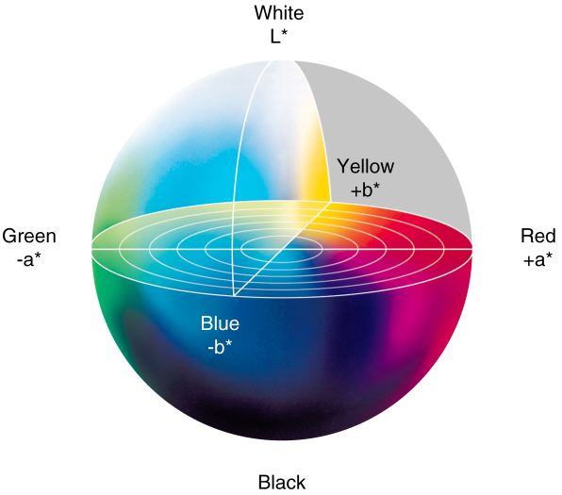
CIELAB Color Map

Edge Detection
While the original paper suggested using Difference-of-Gaussian for edge detection, the method we found uses a derivative-based filter to obtain edge map before it gets altered by color quantization. We first use gradient function to calculate the gradient value of the image. Then we use takes the partial derivative of the result to calculate the edge strength. After obtaining the resulting edge map, we set the luminance to 0 so it does not interfere with the color quantization process. Although canny edge detection is much more sophisticated and can detect real edges on the object, the results from canny detection tend to be disconnected. We also choose to use the derivative-based edge detection method for efficiency reason.

Color Quantization
The next step is to quantize image so that the colors are abstracted to show a cartoon effect. Quantization also reduces the amount of data needed when transferring images.
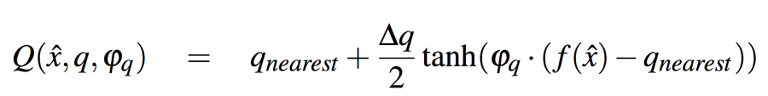
This equation is proposed in Winnemöller, Olsen, Gooch (2006) for image abstraction. Here is an explanation of the variables extracted from the paper

In this equation, Q(·) is the pseudo-quantized image, ∆q is the bin width, q_{nearest} is the bin boundary closest to f (xˆ), and φ_{q} is a parameter controlling the sharpness of the transition from one bin to another (top inset, Figure 2). [This equation] is formally a discontinuous function, but for sufficiently large φ_{q}, these discontinuities are not noticeable.

This helps create a paint like effect. The sharpness parameter φq is further defined as a function of luminance gradient in the original image. This creates sharp bin boundaries only when luminance gradient is high. This creates relatively less color (and thus data) used but also achieve the effect of cartoonification. According to the original paper, another advantage of this pseudo-quantization implementation is the temporal coherence. “In standard quantization, an arbitrarily small luminance change can push a value to a different bin, thus causing a large output change for a small input change, which is particularly troublesome for noisy input. With soft quantization, such a change is spread over a larger area, making it less noticeable. Using our gradient-based sharpness control, sudden changes are further subdued in low-contrast regions, where they would be most objectionable.”

Conversion & Outline
The last step in the initial cartoonification process is to convert the image from CIELAB back to sRGB and change the luminance of the edge map to 1 so that the original edge map created will show up as black outline for the bilaterally-filtered image.

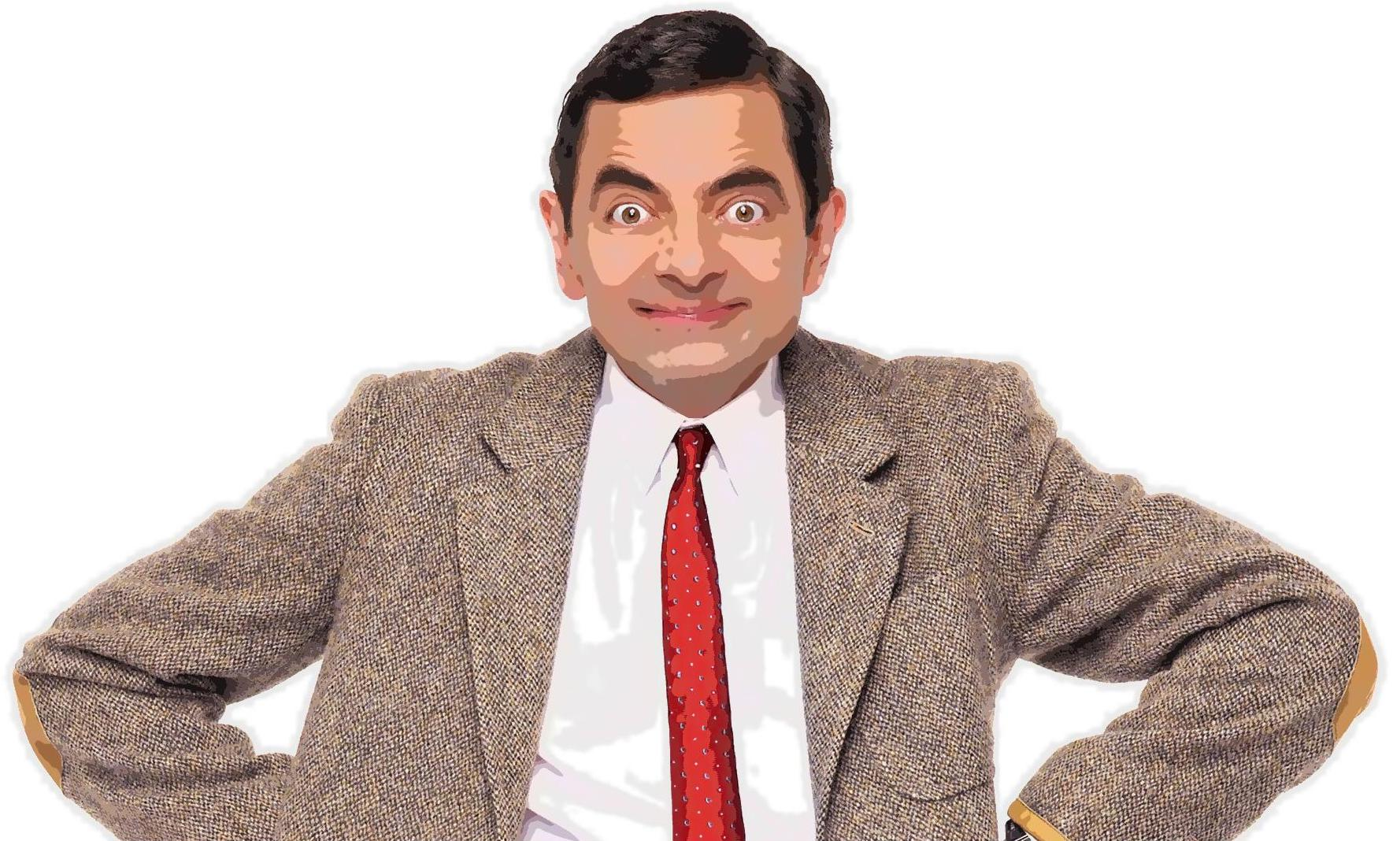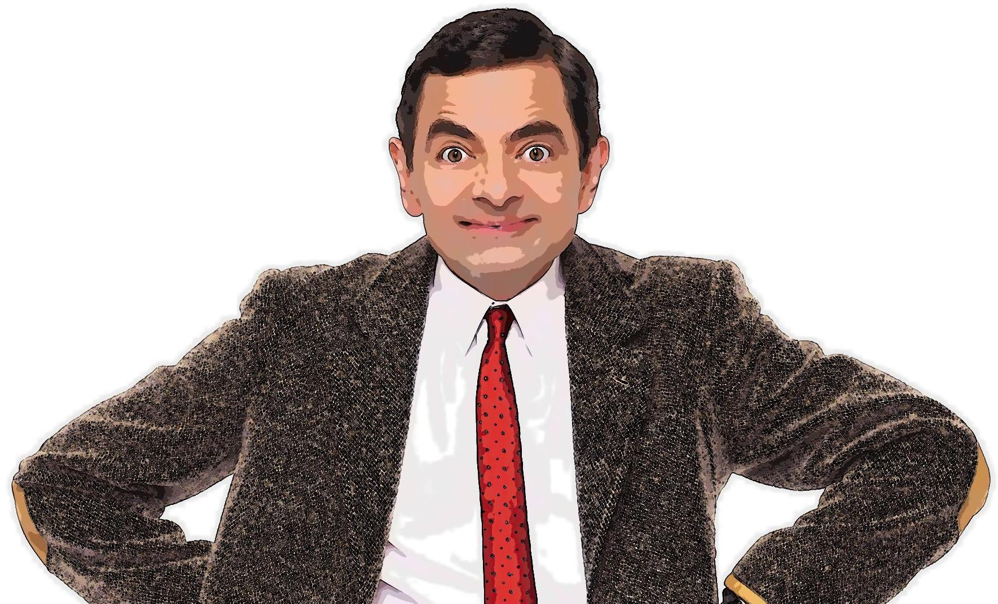
A photo of Mr. Bean and a cartoonified version of Mr. Bean.

The last step is to use repmat function to outline the edges previous detected in the edge map. The two images above illustrate the continuous edge map we obtained through gradient and the result of repmat function.

Thicker Outline
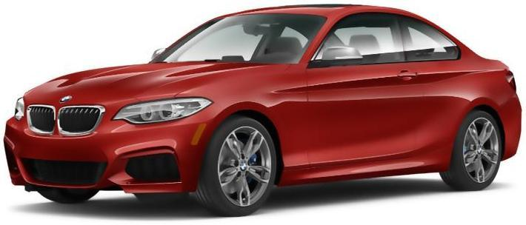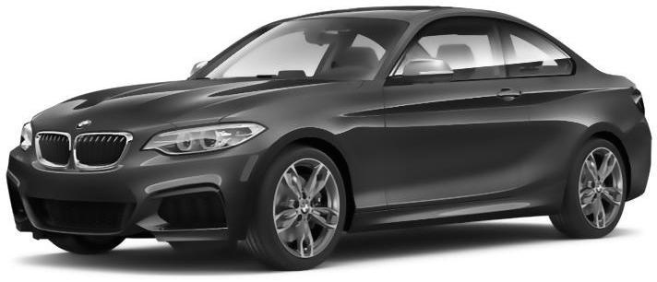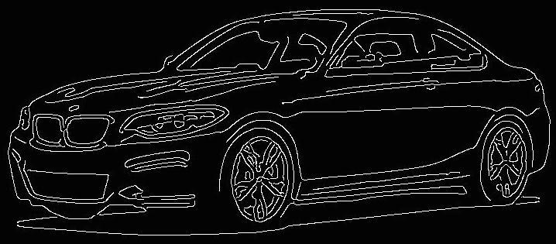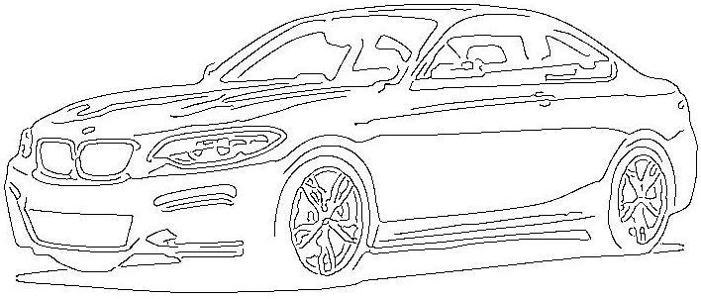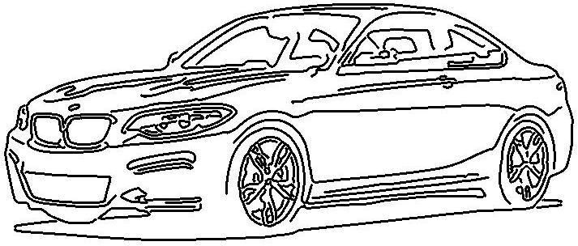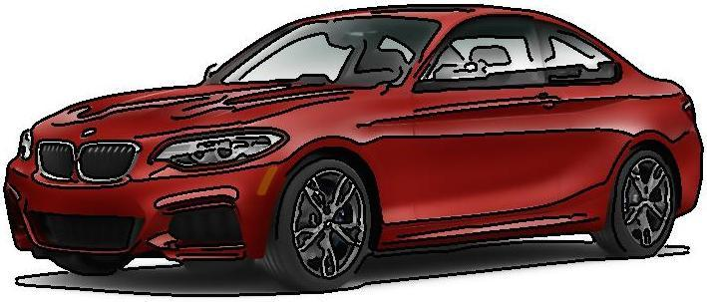
Images showing the steps we took to create the thicker lines. 1) The bilaterally filtered image. 2) The image converted to grayscale for canny edge detection. 3) The result of applying canny edge detection. 4) The inverse of the canny edge detection to get black where we would want black in the final image. 5) The dilated lines produced by canny edge detection. 6) The final image with lines added to the colored image.

To experiment with stylization of the cartoonifying, we tried to create another version of the cartooning with thicker lines. To achieve this effect, we used Matlab’s canny edge detection function to find the edges of the image, then used a disk-shaped structuring element to dilate the edges to make them thicker. We experimented with different thresholds but decided that a lower threshold would be better because it finds fewer edges and cartoons are generally simple. We dilated the edges only minimally because our images were generally small and lines that were too thick overwhelmed the colors. Finally, we added the thick lines to the image with cartoonified colors by point-by-point-multiplying each of the channels of the RGB image by the line image so the parts that were colored were multiplied by 1 and retained their color while the parts that we wanted to replace with lines were multiplied by 0 and became black.

Results and Discussion
Cartoon
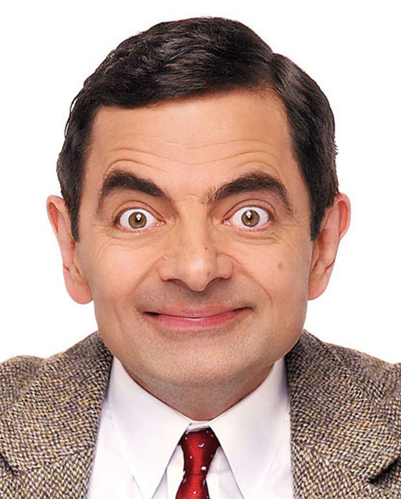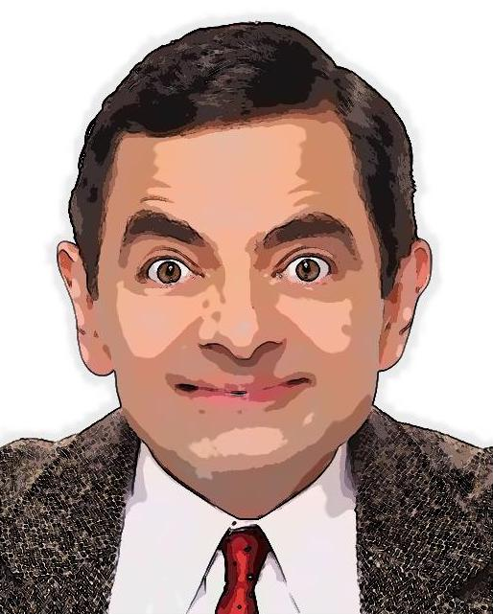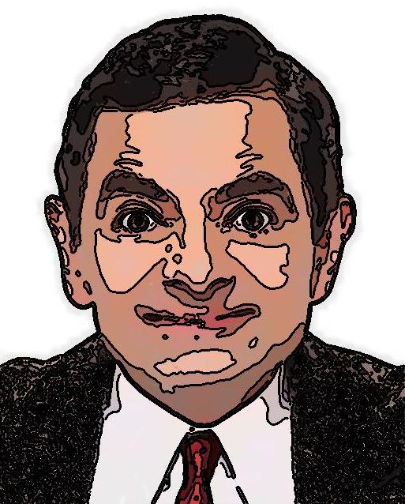
A photo of Mr. Bean, Mr. Bean cartoonified colors and soft edges, Mr. Bean with cartoonified colors and thicker edges.

The cartoon function helps to quantize color and draw relatively coherent lines around the features with significant gradient changes. The effect works well on both human and objects. The cartoon effect gives Mr. Bean’s face a paint like effect. The soft luminance quantization also resembles to certain degree a semantic-driven edge detection effect by reading the light information on Mr. Bean’s face.
There are a few drawbacks of this result when performed on human face. Comparing to a more semantic-driven approach with facial feature recognition, this method with only gradient measurement fails to take into account facial features such as double chin. Mr. Bean’s double chin and the lighting on it causes that area to be put into the same bin as the rest of his chin instead of his neck. This results in a weird area that protrudes out of his chin after the cartoon function is applied. In addition, the method also introduces unnecessary shadow onto the original image due to the quantization. Moreover, the method does not perform as well when it comes to images of relatively higher resolution or fabrics (Human Face #2). The thickness of the outline does not increase with the increase in resolution. Therefore, the outline will not be apparent until the user has zoomed in to focus on the edges. In addition, the threshold fails to exclude objects such as fabrics that have dense pattern of high contrast. Looking at the picture, it is easy to see that the edge detection is also performed on his jacket and has altered its original color.
The third image shown above uses canny edge detection to find and draw thicker lines on Mr. Bean’s face. Although canny edge detection works rather well for objects, it does not really work well at all for the human face. It picks up too many shadows that probably should not be highlighted.

Lines
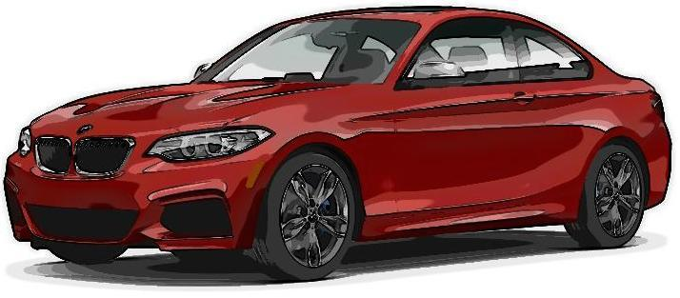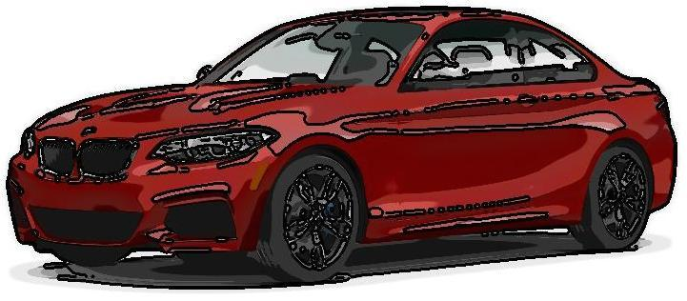
An image of a car cartoonified with soft edges found using a gradient and an image of a car cartoonified with thick lines found using canny edge detection.

We ended up testing two styles of lines - soft edges found using a gradient, and thick edges found using canny edge detection. The gradient method detects fewer edges, which produces a cleaner image, but also has the potential to leave out edges we want highlighted (especially for images of people). The canny edge detection method detects more edges, but some of the edges are produced by shadows and are not actually edges we want (also especially for images of people).
It is also worth noting the thickness of lines that looks good for an image depends on the image’s resolution. For high resolution images, thin lines, like the single pixel wide lines produced by our cartoon function, are practically invisible without zooming in, so lines have to be dilated significantly to produce any stylization effect. For low resolution images, even a slight dilation of the lines might be overwhelming, as the lines would cover too much of the color and take away from the image.

Results using Different Types of Images
Human Face #1

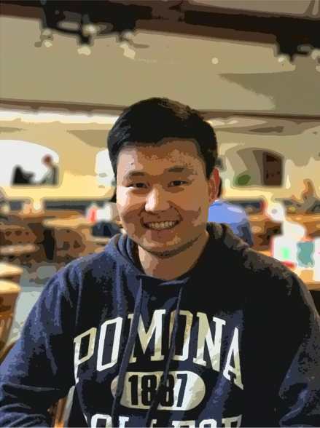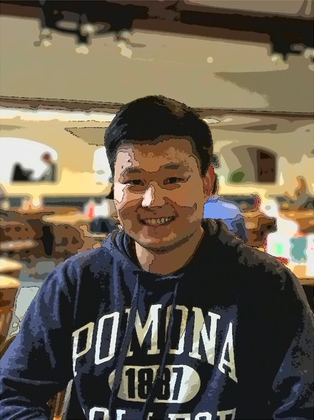
Human Face #2

Object #1

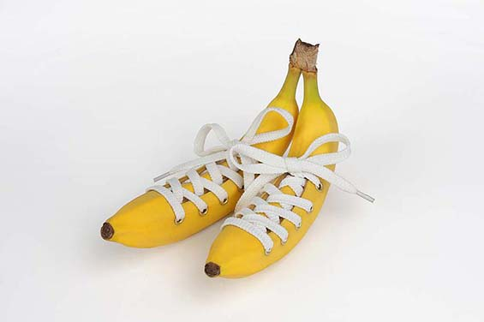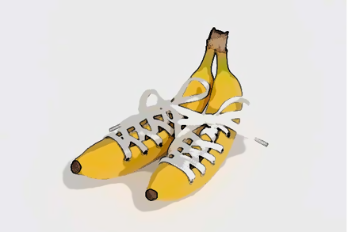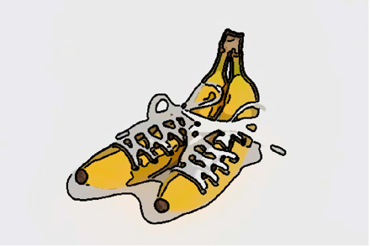
Object #2

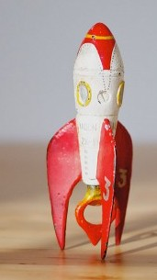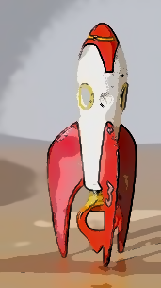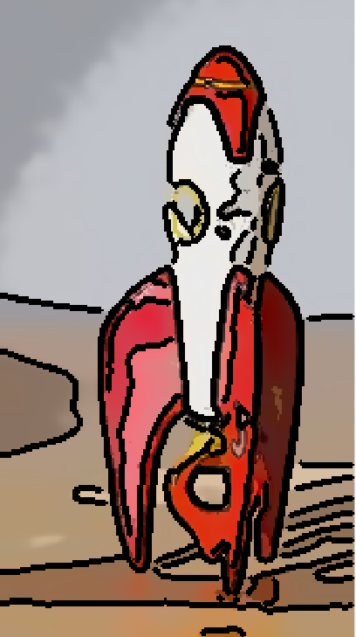
Object #3
From these results, we can see that our cartoonification method works better for objects than for humans. This can in part be contributed to the different expectation of the cartoon effect on human and on objects. We would not normally be concerned with some irregularity such as small blotches on images of objects thinking it might be part of the cartoon. However, we often hold a higher standard for a cartoon face to have a closer resemblance to human face, and blotches often have a big effect in that case. When the canny edge detector is used, many shadows are highlighted – in the case of objects, outlining certain shadows might add to the style of the cartoon, but in the case of a human face, extensive lines on the face are very distracting.
For low-resolution images like the rocket (Object #3), the slight graininess in the original image (along with the similar color of parts of the foreground and the background) makes it so that the resulting lines are not very smooth. And for high-resolution images like the second person’s face (Human Face #2), the lines are barely visible despite the dilation because the original image is too large.

Further Development
We think that better edge detection is a major future development goal. Better lines can maintain clarity of what is going on in the image even if more colors are eliminated, and also add an element of style. According to Kang et al, line drawing uses the minimal amount of data but can still convey object shapes to the viewer and do so even better than photorealistic imagery. We tested two methods, neither of which worked entirely to our satisfaction (the gradient method left out too many edges and the canny detection method found too many). We did, however, read about coherent line drawing, which looks like a promising way to create clean, accurate lines for images, even of people. Unfortunately, we don’t think coherent line drawing can be implemented in matlab, so we did not have a chance to use it in our project. Still, it would be a good direction to go in the future. Feature detection is another potential way to improve the lines for images of people although we did not really look into it. But theoretically it would ensure that features like noses and eyes were outlined correctly.
Another potential direction we could take the project is caricaturing. It would be interesting to detect features on a face and replace them with cartoon versions of the features to exaggerate them. For example, if we detected an eye, we could replace it with an eye cropped out of a Disney cartoon that maybe had the same color. Or if we detect a nose that seems large given a comparison of its size to the size of the face, we could replace it with a caricatured large nose. Caricaturing is generally done by human artists, but there’s no reason why a computer cannot learn to compare features to “average” features and exaggerate them accordingly.

References
Barlow, H. B., Blakemore, C., & Weston-Smith, M. (1990). Images and understanding: Thoughts about images, ideas about understanding. Cambridge: Cambridge University Press.
Erdelyi, A., Barat, T., Valet, P., Winkler, T., & Rinner, B. (2014, 08). Adaptive cartooning for privacy protection in camera networks. 2014 11th IEEE International Conference on Advanced Video and Signal Based Surveillance (AVSS). doi:10.1109/avss.2014.6918642
Han, M., Song, H., & Yoon, K. (2010, 08). Cartooning Using Reference Images. 2010 3rd International Conference on Human-Centric Computing. doi:10.1109/humancom.2010.5563326
Kang, H., Lee, S., & Chui, C. K. (2007). Coherent Line Drawing. Proc. ACM Symposium on Non-photorealistic Animation and Rendering.
Madeira, J. S., Stork, A., & Groß, M. H. (1996, 01). An approach to computer-supported cartooning. The Visual Computer, 12(1), 1-17. doi:10.1007/bf01782215
Pearson, E. D. & Robinson J. A. (1985). Visual Communication at Very Low Data Rates. Proceedings of the IEEE, 73(4).
Shahcheraghi, Z., & See, J. (2013, 10). On the effects of pre- and post-processing in video cartoonization with bilateral filters. 2013 IEEE International Conference on Signal and Image Processing Applications. doi:10.1109/icsipa.2013.6707974
Winnemöller, H., Olsen, S. C., & Gooch, B. (2006). Real-time video abstraction. ACM SIGGRAPH 2006 Papers on - SIGGRAPH '06. doi:10.1145/1179352.1142018
Yang, M., Lin, S., Luo, P., Lin, L., & Chao, H. (2010, 09). Semantics-driven portrait cartoon stylization. 2010 IEEE International Conference on Image Processing. doi:10.1109/icip.2010.5651715

